**LAB REPORT NO 8**



**CSE-206L Electronic Circuits Lab**

Submitted by:  **Muhammad Ali**

Registration No: - **19PWCSE1801**

Class Section: A

“On my honor, as student of University of Engineering and Technology, I have neither given nor received unauthorized assistance on this academic work.”

Submitted to:

**Engr. Abdullah Hamid**

Data:(30,06,2021)

Department of Computer Systems Engineering

University of Engineering and Technology, Peshawar

**BJT Circuit: -**

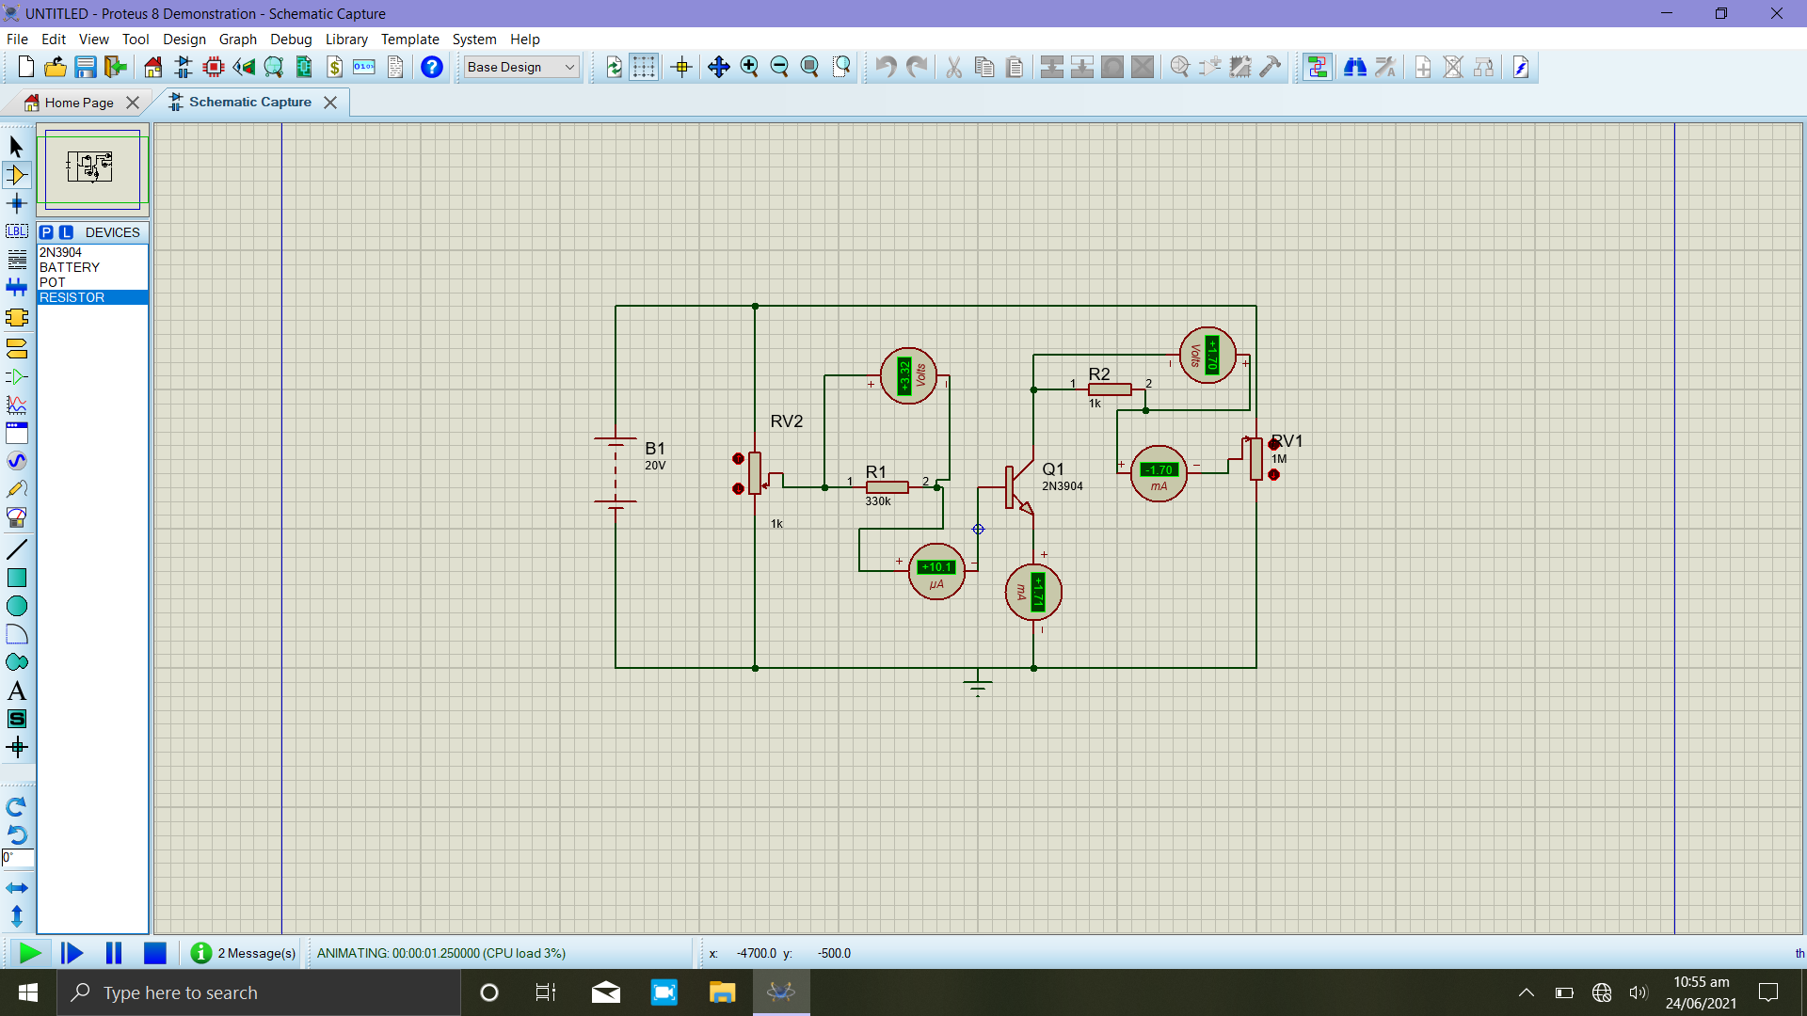

**First reading: -**

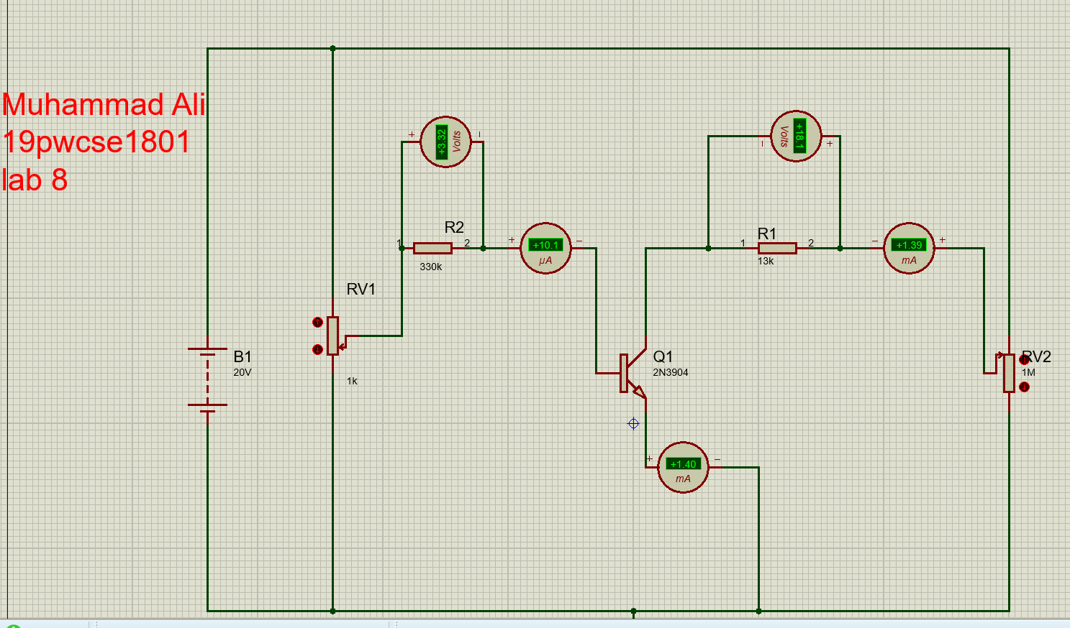

**Second reading: -**

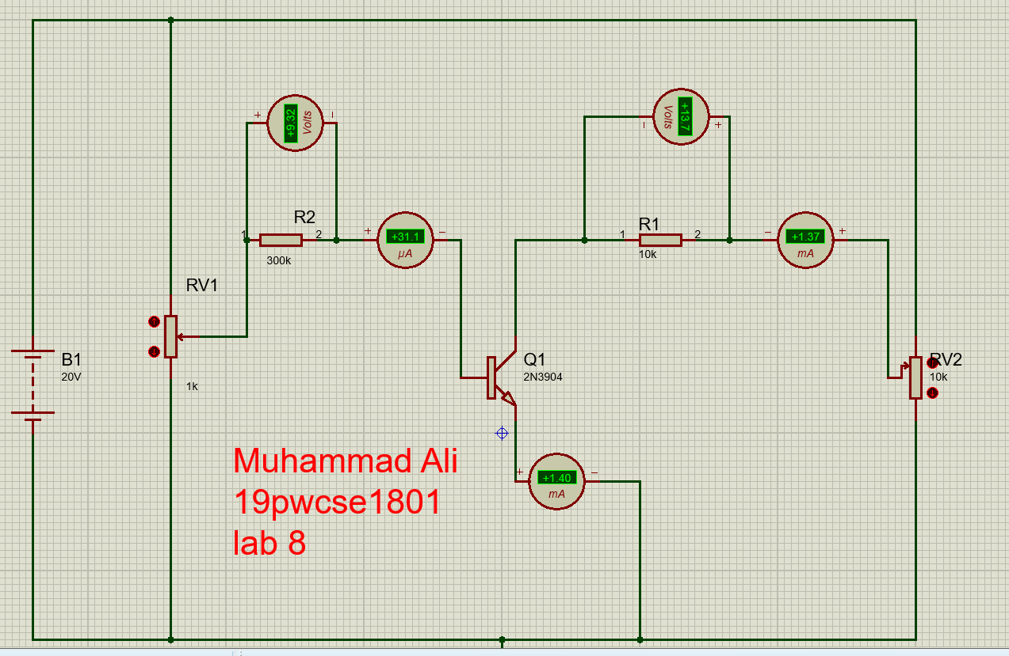

**Third reading: -**

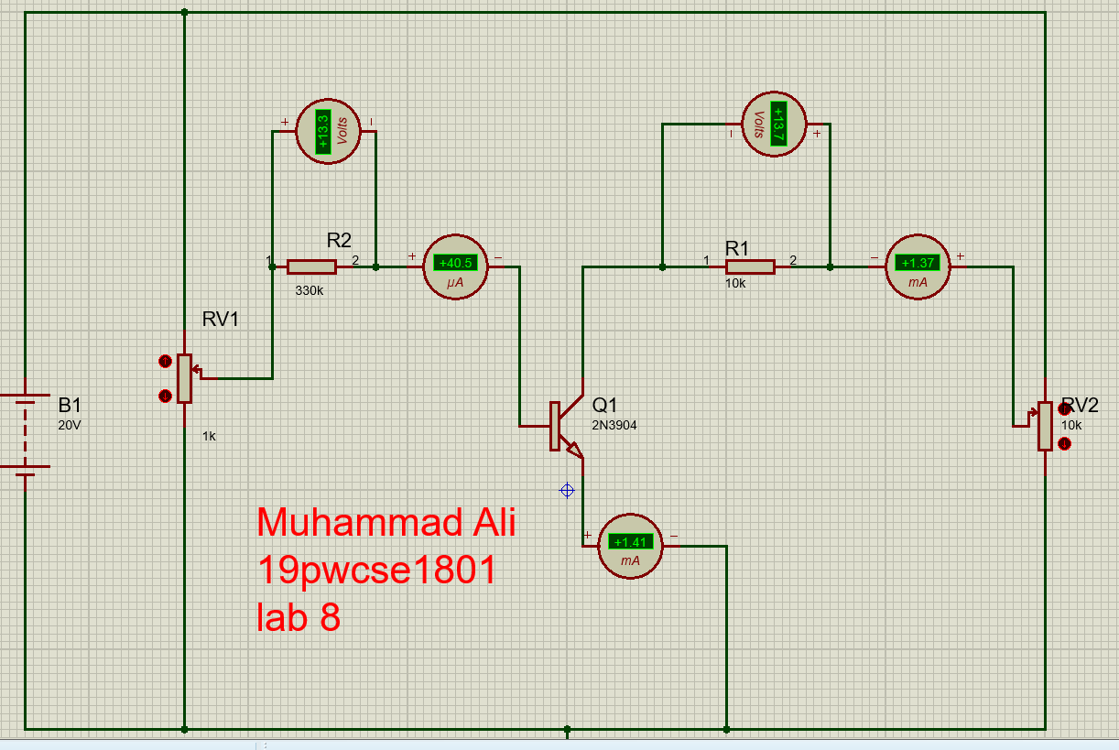

**Fourth reading: -**

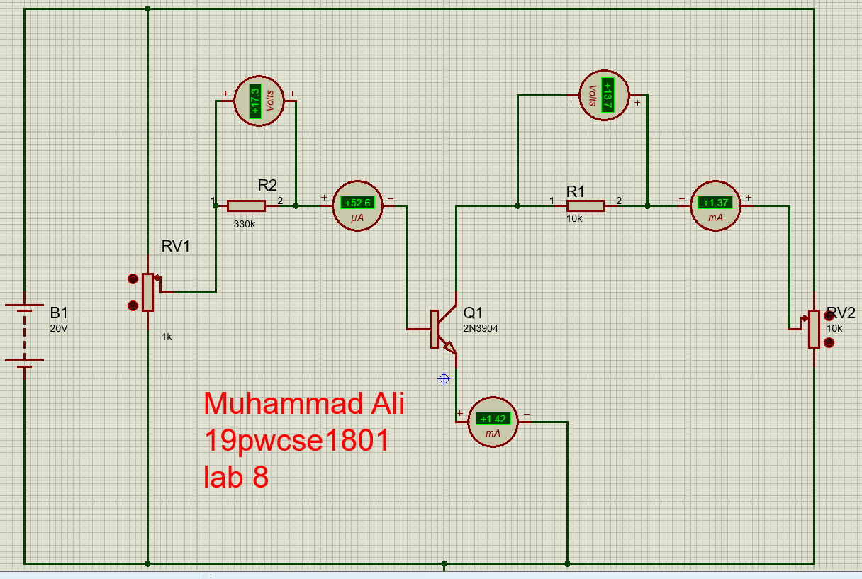

**Overall reading and calculation: -**

|  |  |  |  |  |  |  |  |  |
| --- | --- | --- | --- | --- | --- | --- | --- | --- |
| **VR2 (v)** | **IB (µA)** | **VCE(v)**  **=VDC-VCC** | **VRC(v)** | **IC (mA)** | **VBE (v)** | **IE (mA)** | **α (Collector gain)** | **β (emitter gain)** |
| 3.3 | 10.1 | 1.9 | 18.1 | 1.39 | 0.7 | 1.40 | 0.9 | 137 |
| 4 | 16.0 | 1.46 | 0.7 | 1.47 | 0.9 | 144 |
| 5.7 | 14.3 | 1.43 | 0.7 | 1.44 | 0.9 | 141 |
| 7.4 | 13.6 | 1.36 | 0.7 | 1.37 | 0.9 | 134 |
| 10.5 | 9.55 | 0.95 | 0.7 | 0.96 | 0.9 | 94 |
| 12.1 | 7.88 | 0.79 | 0.7 | 0.80 | 0.9 | 78 |
| 13.7 | 6.3 | 0.63 | 0.7 | 0.64 | 0.9 | 62 |
| 16.6 | 3.35 | 0.34 | 0.7 | 0.35 | 0.9 | 33 |
| 5.3 | 20.5 | 3.6 | 16.4 | 1.64 | 0.7 | 1.66 | 0.98 | 80 |
| 6.3 | 13.7 | 1.37 | 0.7 | 1.39 | 0.98 | 66 |
| 8.5 | 11.5 | 1.15 | 0.7 | 1.17 | 0.98 | 56 |
| 10.4 | 9.58 | 0.96 | 0.7 | 0.98 | 0.97 | 46 |
| 12.9 | 7.91 | 0.79 | 0.7 | 0.81 | 0.97 | 38 |
| 13.6 | 6.36 | 0.64 | 0.7 | 0.66 | 0.96 | 31 |
| 9.3 | 31.2 | 3.6 | 16.4 | 1.64 | 0.7 | 1.67 | 0.98 | 52 |
| 6.3 | 13.7 | 1.37 | 0.7 | 1.40 | 0.98 | 43 |
| 8.5 | 11.5 | 1.15 | 0.7 | 1.18 | 0.98 | 36 |
| 10.4 | 9.58 | 0.96 | 0.7 | 0.99 | 0.96 | 31 |
| 13.6 | 6.36 | 0.64 | 0.7 | 0.67 | 0.95 | 30 |
| 13.3 | 40.5 | 3.6 | 16.4 | 1.64 | 0.7 | 1.68 | 0.97 | 40 |
| 6.3 | 13.7 | 1.37 | 0.7 | 1.41 | 0.97 | 33 |
| 8.5 | 11.5 | 1.15 | 0.7 | 1.19 | 0.96 | 28 |
| 10.4 | 9.58 | 0.96 | 0.7 | 1.0 | 0.96 | 25 |
| 17.3 | 52.1 | 3.6 | 16.4 | 1.64 | 0.7 | 1.69 | 0.99 | 33 |
| 6.3 | 13.7 | 1.37 | 0.7 | 1.42 | 0.99 | 27 |
| 8.5 | 11.5 | 1.15 | 0.7 | 1.20 | 0.95 | 23 |